**Simple Mail Transfer Protocol (SMTP)**

Email is emerging as one of the most valuable services on the internet today. Most internet systems use SMTP as a method to transfer mail from one user to another. SMTP is a push protocol and is used to send the mail whereas POP (post office protocol) or IMAP (internet message access protocol) are used to retrieve those mails at the receiver’s side.

**SMTPFundamentals**   
SMTP is an application layer protocol. The client who wants to send the mail opens a TCP connection to the SMTP server and then sends the mail across the connection. The SMTP server is always on listening mode. As soon as it listens for a TCP connection from any client, the SMTP process initiates a connection through port 25. After successfully establishing a TCP connection the client process sends the mail instantly.

**SMTP Protocol**

The SMTP model is of two types:

1. End-to- end method
2. Store-and- forward method

The end to end model is used to communicate between **different organizations** whereas the store and forward method is used **within an organization**.

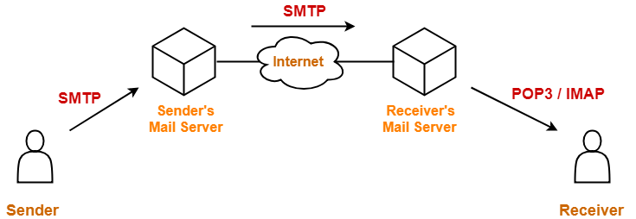

ALGORITHM:

1.START

2.Set Senders Mail Address and Password.

3.Get System Properties and put host,port,ssl enable to the property object.

4.Ask the Receivers Mail Address.

5.Get the Session object for the processed password authentication purpose.

6.Create a default Mime Message object to receive the message from the user/sender.

7.Ask the User the Subject and the Message to send it to the reciver.

8.Send the Message and Display the Result.

9.STOP

**SOURCE CODE**

package com.sendemail;

import java.util.Properties;

import java.util.*;

import javax.mail.Message;

import javax.mail.MessagingException;

import javax.mail.PasswordAuthentication;

import javax.mail.Session;

import javax.mail.Transport;

import javax.mail.internet.InternetAddress;

import javax.mail.internet.MimeMessage;

public class SendMail {

public static void main(String[] args) {

Scanner inp = new Scanner(System.*in*);

String from = "machinelearning1308@gmail.com";

String[] arrOf = from.split("@");

System.*out*.println("\n\tWelcome "+arrOf[0]+"\n");

System.*out*.println("Type **YES** to send mail !!\n");

String ans = inp.nextLine();

if (!ans.equalsIgnoreCase("yes")) {

System.*out*.println("Okay Leaving ..!!");

return;

}

else {

System.*out*.print("Enter to address: ");

String to = inp.nextLine();

String host = "smtp.gmail.com";

Properties properties = System.*getProperties*();

properties.put("mail.smtp.host", host);

properties.put("mail.smtp.port", "465");

properties.put("mail.smtp.ssl.enable", "true");

properties.put("mail.smtp.auth", "true");

Session session = Session.*getInstance*(properties, new javax.mail.Authenticator() {

protected PasswordAuthentication getPasswordAuthentication() {

return new PasswordAuthentication("machinelearning1308@gmail.com", "mbAbi@13!");

}

});

session.setDebug(true);

try {

MimeMessage message = new MimeMessage(session);

message.setFrom(new InternetAddress(from));

message.addRecipient(Message.RecipientType.*TO*, new InternetAddress(to));

System.*out*.println("Enter Subject: ");

message.setSubject(inp.nextLine());

System.*out*.println("Enter your Message : ");

message.setText(inp.nextLine());

System.*out*.println("\nSending Mail...\n");

Transport.*send*(message);

System.*out*.println("\nSent message successfully....");

}

catch (MessagingException mex) {

mex.printStackTrace();

}

}

}

}

**OUTPUT SCREENSHOT**

